Table of Contents

1. Introduction 2

1.1. Purpose of Plan 2

1.2. Project Scope and Objectives 2

1.2.1. Statement of Scope 2

1.2.2. Major Functions 2

1.3. Overview of Document 3

2. Project Organization 3

2.1. Process Model 3

2.2. Team Structure 3

2.3. Communication 4

2.4. Reporting 5

3. Project Resources 5

3.1. Hardware and Software 5

4. Risk Management Plan 6

4.1 Likely risks: 6

5. Testing 7

6. Schedule 7

6.1. Project Breakdown 7

6.2. Time Line 7

6.3. Task Network Diagram 10

4. Objective Grading Sheet 13

7. Tracking and Control Mechanics 14

8. References 14

9. Glossary 15

# 1. Introduction

The purpose of this plan is to evaluate the available resources, to describe the scope and objectives of the project and its major functions. It also describes the process model, team structure and also likely risks that are likely to raise during the development of the project.

# 1.1. Purpose of Plan

The purpose of this document is to describe the available resources that are needed to complete the project successfully, as well as the plan. This document elaborately discusses the important tasks, duties to perform and their management. Additionally, foreseen risk analysis and methods for risk mitigations are reviewed. Moreover, the time line, milestones, responsibilities and roles of the team members and methods for quality assurance, reporting and backup plans are also specified.

# 1.2. Project Scope and Objectives

# 1.2.1. Statement of Scope

The main purpose of this project is to help the user to search for tickets for different events and reserve the ticket for that event. This is a web based application and we are using some languages like C#, .net, HTML, CSS and Java Scripts for the front end and SQL server for the backend as well. In this system, there are three types of users: registered, guest and admin users. Registered users and guest users can reserve the ticket and cancel the ticket. The admin is also considered as a type of user since he is using this system to perform some tasks. Admin users manage the reservation system. This system will not handle payment. So the user has to collect the ticket at the counter by paying the required money. The Guests and registered users cannot choose a particular seat.

# 1.2.2. Major Functions

The main functionalities of this system are:

User Login: Guest user can create an account and can login with their username and password. They can update the account information and can also delete the account.

Admin maintaining database: Admin login in the system and have the permissions to make changes to events such as updating the price, deleting the event and so on. The admin cannot delete or alter the information about the user.

# 1.3. Overview of Document

The following document is arranged as follows, section one describes the purpose and the objective of the plan document. Section two specifies the process model and team structure. Hardware and software requirements, risk management are also included in the third and fourth section of the document. The schedule of the project, tracking and control mechanics followed by glossary are discussed in the further sections.

# 2. Project Organization

Project organization handles the project activities based on the particular project model and guidelines. Project organization creates an environment that helps the team member to coordinate and interact with each other and solves the different issues that arise during the project development.

# 2.1. Process Model

As this system is small, and all requirements are understood clearly at the beginning phase, so waterfall model is used. Waterfall model has mainly five phases and each phase is completed before the next phase can begin. In the requirement phase, all the requirements of the project are gathered. Then, in design phase, different design diagram as use case, sequence is created. The actual code is written in the implementation phase. The verification phase is used to check whether the project has met the customer requirements or not. The final phase is maintenance where after handling the system if some issues arises, it is resolved.

# 2.2. Team Structure

Team members of our project are listed below.

* Nagendra Babu Pasupuleti
* Avinash
* Prakriti
* Gayatri Bhimani

According to the skills and expertise required, the role played by each member of the team may change during the process of development. Dr. Catherine Stringfellow will be monitoring the project. Roles played by the team members are listed below.

* Team Leader (Nagendra)
* Documents Reviewer (Everyone)
* DB Developer (Avinash)
* DB Peer Reviewer (Gayatri)
* DB Tester (Prakriti)
* UI Developer (Prakriti, Nagendra)
* UI Peer Reviewer (Avinash)
* UI Tester (Gayatri)
* Core Developer (Nagendra, Avinash)
* Core peer Reviewer (Prakriti, Gayatri)
* Core Tester (Prakriti, Gayatri)

In this project we are following a controlled decentralized structure where the team leader will make decisions with the opinion of team members. The roles to be played by the team members will be decided by the team leader based on the skills and expertise and will set the expectation of that role for that situation and will estimate the outcome for that role.

# 2.3. Communication

The communication between the team members will be through e-mails and regular meetings. During team meetings, the status of the project is discussed, individual goals are set and analysis is done on the previously set goals. The problems and their possible solutions are explored. If the situation demands, micro teams are formed within the team. Checkpoints like milestones, timeline of the project etc., are checked. Individual and team log tables are maintained and they will available to all the team members. The source code is shared by using GitHub.

# 2.4. Reporting

The team leader is responsible for everything and in his/her absence next supporting leader will take the charge as a team leader. She/he arbitrates the conflicts between the team members. Issues are logged and were discussed in immediate team meeting. If things are get out of control, the course instructor, Dr. Stringfellow, will have the final word in resolving the issues.

# 3. Project Resources

# 3.1. Hardware and Software

The project development environment will be as follows:

**Hardware** will include a personal (desktop or notebook) computer with the following specifications:

* a Pentium 4 microprocessor running at 2.0 GHz or above
* a minimum of 128 megabytes of system RAM
* a hard drive with at least 2 gigabytes of free space
* an XGA screen display 14” or larger
* a graphics card with 16 megabytes or more of RAM

**Software** will include:

* Windows 7
* Microsoft Visual Studio 2015
* SQL Server
* Microsoft Project

The customer’s environment will be as follows:

**Hardware** will include a personal (desktop or notebook) computer with the following specifications:

* a Pentium 4 microprocessor running at 2.0 GHz or above
* a minimum of 128 megabytes of system RAM
* a hard drive with at least 2 gigabytes of free space
* an XGA screen display 14” or larger
* a graphics card with 16 megabytes or more of RAM

**Software** utilized will include:

* Windows 2000 or above
* a web browser.

# 4. Risk Management Plan

# 4.1 Likely risks:

Table below shows a few of the listed possible potential risk.

|  |  |  |  |
| --- | --- | --- | --- |
| **Risk** | **Chance** | **Impact** | **Strategy** |
| Illness of Team Members | Low | Tolerable | Allow a few days buffer. Redistribute work |
| Procrastination | Low | Serious | Have frequent meetings to monitor progress |
| Changes in Requirements | High | Tolerable | Additional effort of the team will be required for solving this problem |
| Compatibility Constraints | Low | Serious | Additional Research |
| Learning Curve for use of Applications | High | Serious | Find and use as much reference material as possible. |

Risk management is important for any project as it leads to many serious issues, so every member of the team should have the knowledge of risks. For this team is being introduced to C#, .net for the first time, but the team has good knowledge on OOPs concepts using C++ and on the user controls present in Visual Studio. In order to fix bugs and to add new features extra effort should be taken by the team.

# 5. Testing

Every version release of the project will be complete with code review, technical review, function review, unit testing and integration testing. This will help the team release a bug free environment and risk free environment.

# 6. Schedule

# 6.1. Project Breakdown

This Schedule will give the outline for the tasks to be performed in the project.

The project goes as follows:

# 6.2. Time Line

The time line divides the project into different tasks and gives detailed description of the project schedule by allocating specific time slots to each task as shown in Figure. Team member is responsible for scheduling the task using Microsoft project. The project schedule is attached along with the network task diagram and the objective grading sheet.

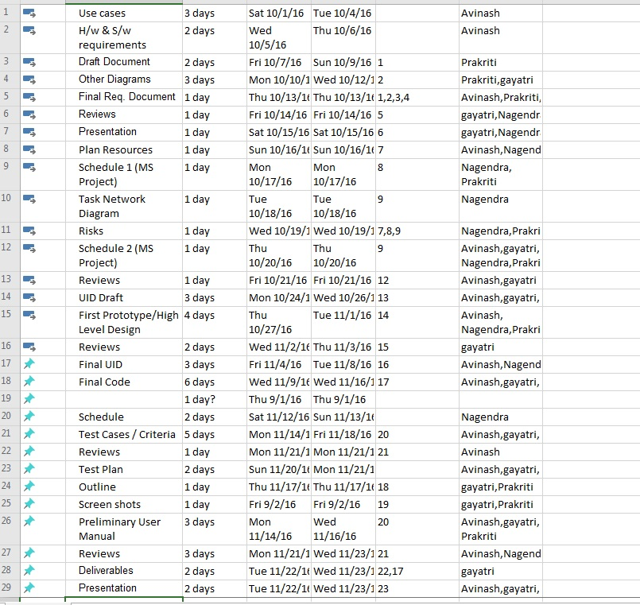

Figure 1. Schedule.

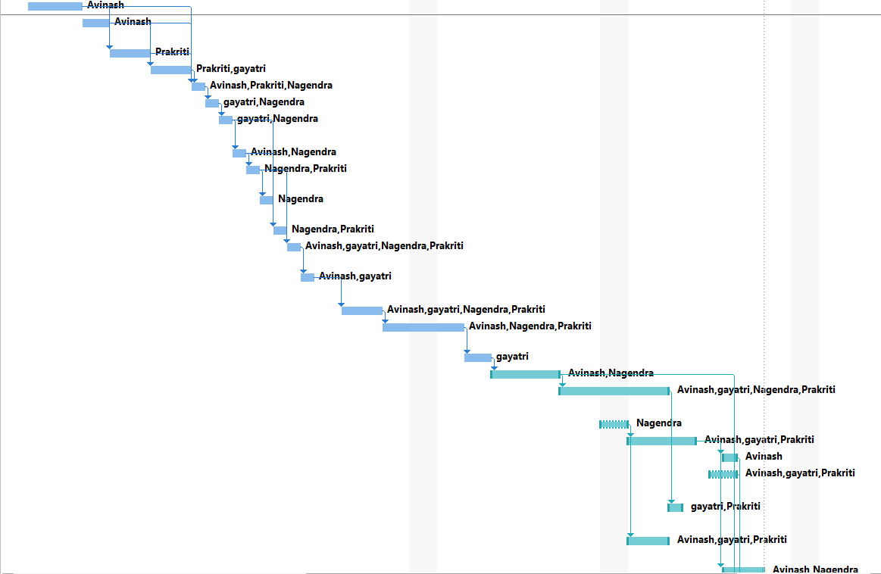

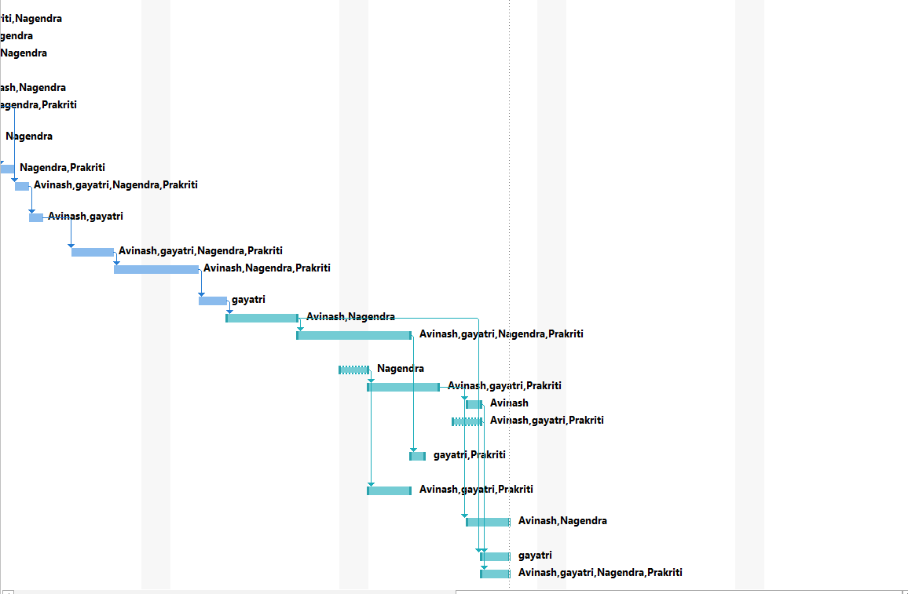Figure 2. Time Line.

# 6.3. Task Network Diagram

The Figure given below shows the tasks and their dependencies

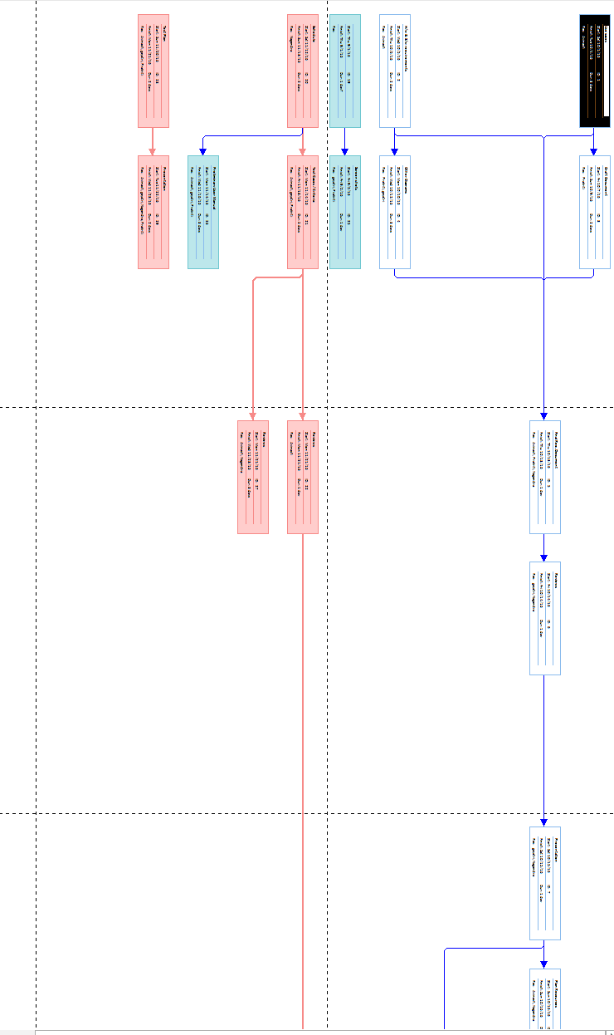

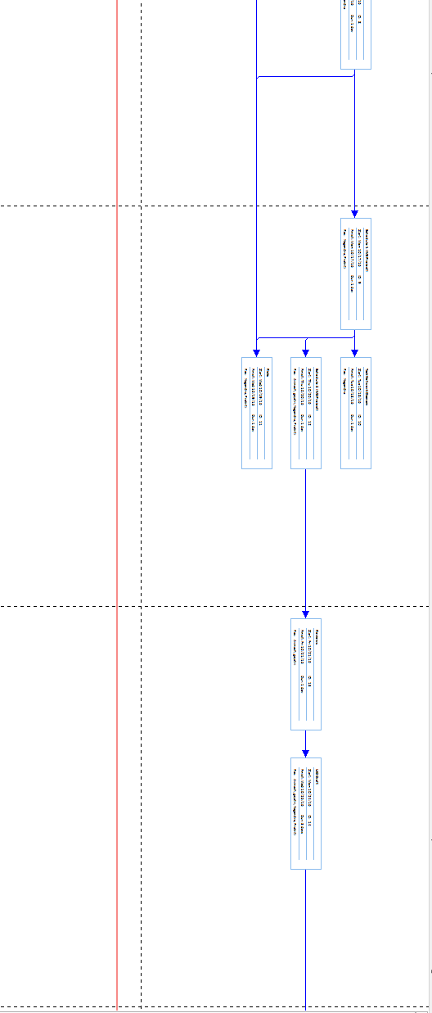

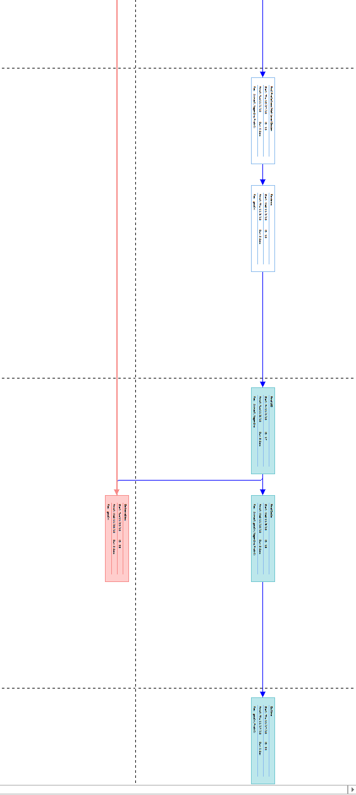

Figure 3. Task network diagram.

# 4. Objective Grading Sheet

The Figure below represents grading sheet of team members and the bold cells are represents completed tasks. 

Figure 4. Objective Grading Sheet

# **7. Tracking and Control Mechanics**

The project will be monitored during the development process to catch any error that may arise. The group will develop a plan to test the software at various stages of the development. The group will also review the requirements and specifications plan to ensure no oversights.

The testing documentation will outline the process that the testers will follow to catch any possible error in the system. Testing will be documented and will state what the errors were and if there were not errors. Such a plan, carefully executed, would ensure the system is deployed with optimal accuracy.

# 8. References

[1]. Sommerville I., Software Engineering 9th edition, Delhi, Pearson Education, Ltd, 2011.

[2]. Pressman Roger S., Software Engineering – A Practitioner’s Approach 7th edition, New York, McGraw-Hill, 2010.

[3]. Uyttewaal E., “Microsoft Project: Plan Better with Microsoft Project”, New York, TechNet Magazine, February 2012.

# 9. Glossary

SQL - Structured Query Language

CSS - Cascading Style Sheets

RTTPS – Real Time Transaction Processing System